Configure a Mail Server on RHEL v9
Mail Server is a software program that sends and receives email. Often, it is used as a blanket term for both mail transfer agents (MTA) and mail delivery agents (MDA) Within the Internet email system, a message transfer agent, or mail transfer agent, or mail relay is software that transfers electronic mail messages from one computer to another using the Simple Mail Transfer Protocol.
mail server setup requirement
- launch a machine on AWS by redhat image
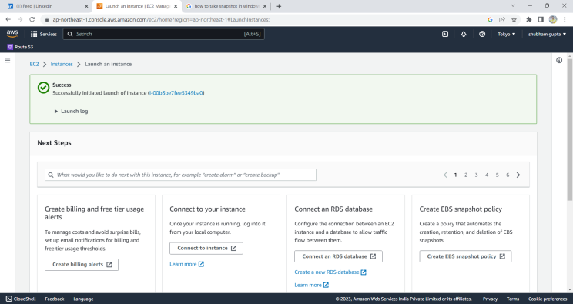
- add port in aws security (smtp=25, imap=143, pop3=110)
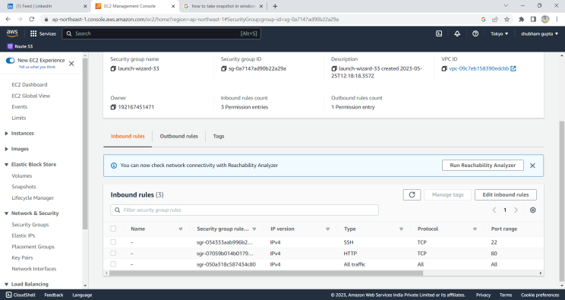
- set a hostname # hostnamectl set-hostname mail.ica.online
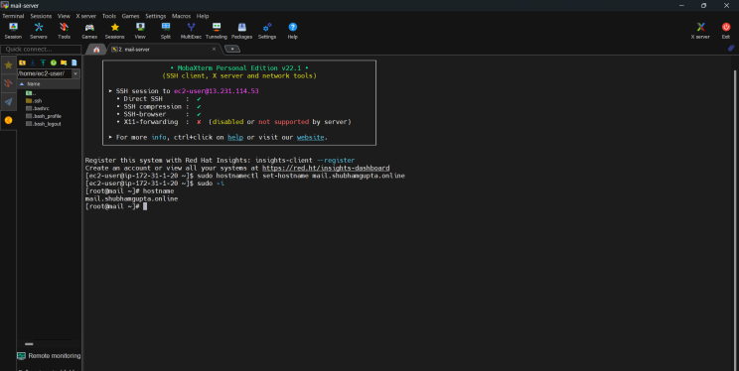
Rhel 9 EPEL configure
# dnf install https://dl.fedoraproject.org/pub/epel/epel-release-latest-9.noarch.rpm -y
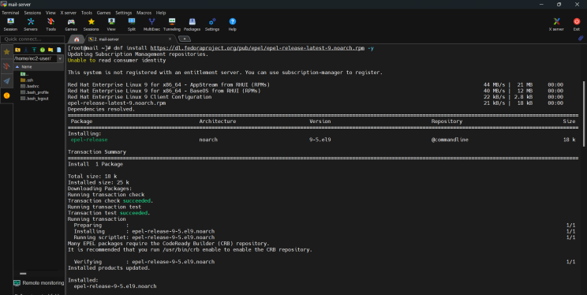
- DNS configure By the help of Route53 AWS service
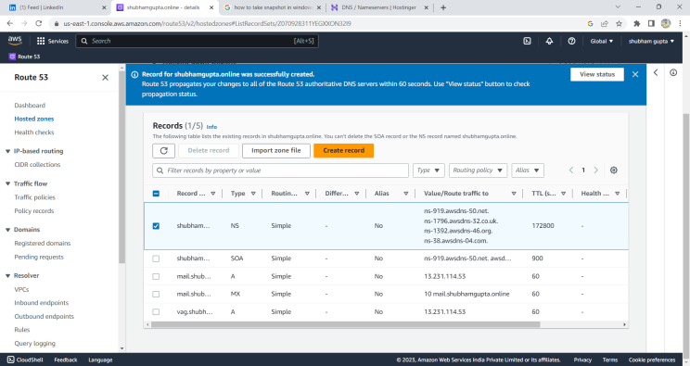
- entry in aws name server in hostinger child nameserver
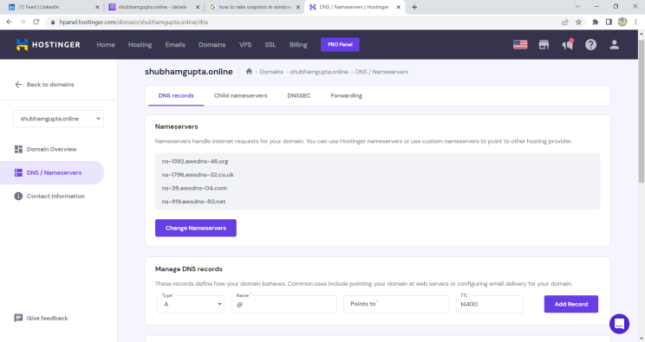
# yum install bind bind-utils -y
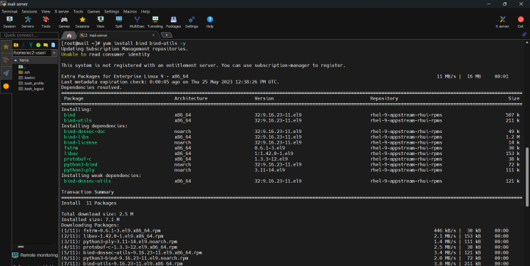
# nslookup mail.shubhagupta.online
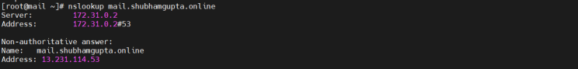
# yum install postfix telnet s-nail -y
# systemctl enable --now postfix
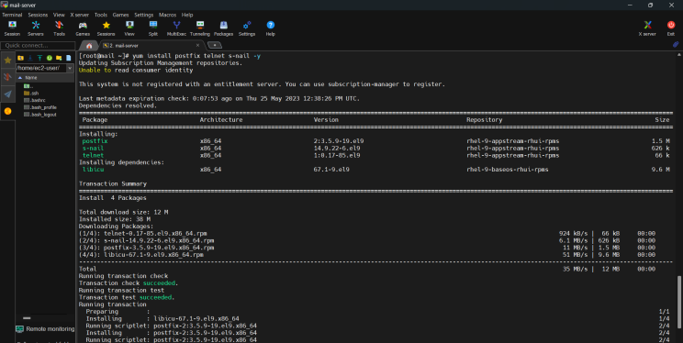
# yum install vim wget -y
# vim /etc/postfix/main.cf
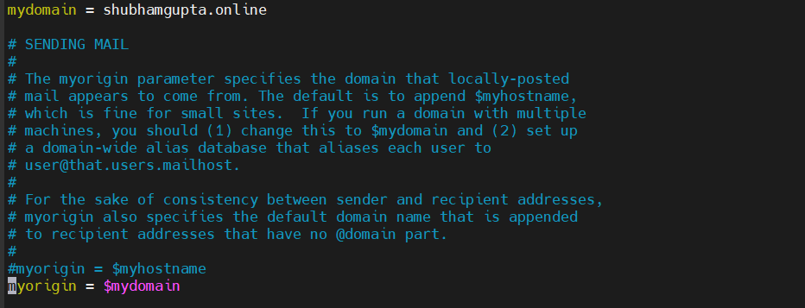
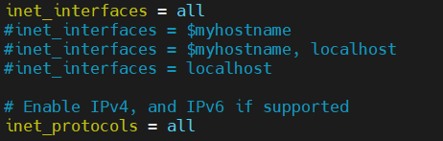
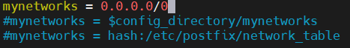
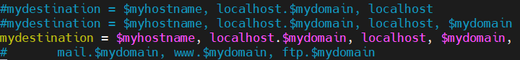
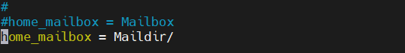
# systemctl status postfix
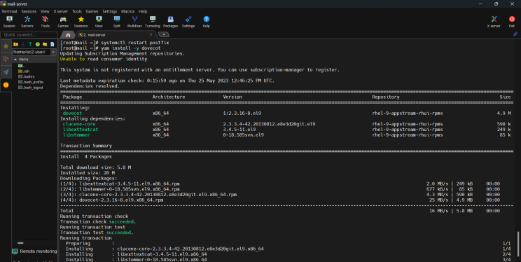
# systemctl restart postfix
yum install -y dovecot
# systemctl enable --now dovecot
# vim /etc/dovecot/dovecot.conf
^ protocols = imap pop3 lmtp submission
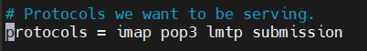
# vim /etc/dovecot/conf.d/10-mail.conf
^ mail_location = maildir:~/Maildir
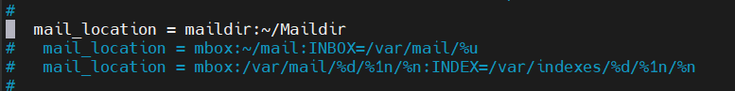
# vim /etc/dovecot/conf.d/10-master.conf
^ unix_listener /var/spool/postfix/private/auth {
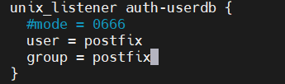
mode = 0660
user = postfix
group = postfix}
#vim /etc/dovecot/conf.d/10-auth.conf
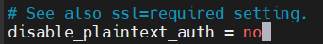
^ disable_plaintext_auth = no
# systemctl restart dovecot
# useradd shubham
# useradd gaurav
# passwd shubham
# passwd gaurav
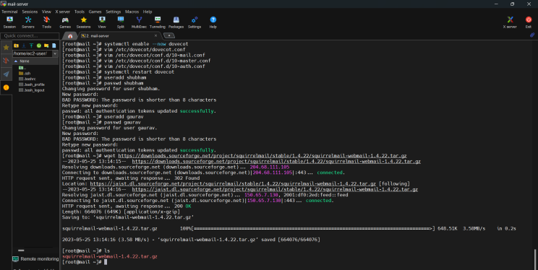
# wget
https://downloads.sourceforge.net/project/squirrelmail/stable/1.4.22/squirrelmail-webmail-1.4.22.tar.gzmv squirrelmail-webmail-1.4.22/* .
# yum install httpd -y
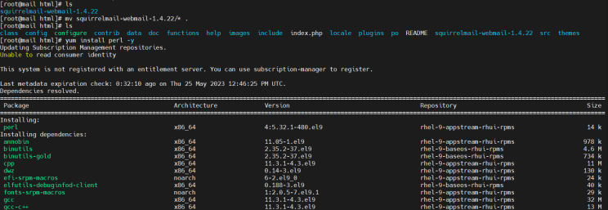
# cd /var/www/html/
# tar -xvf /root/squirrelmail-webmail-1.4.22.tar.gz
# mv squirrelmail-webmail-1.4.22/* .
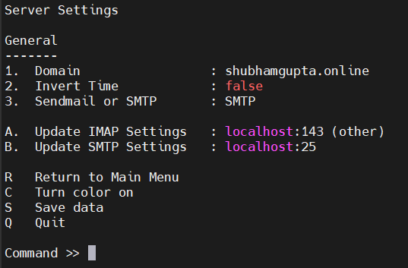
# yum install perl -y
# ./configure

redhat test page show becoz you have this squirrel mail script in php so you have to uninstall php v7.4
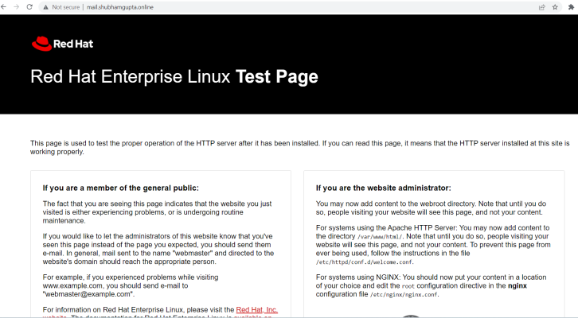
# systemctl restart httpd
# cd
# setenforce 0
# yum install -y https://rpms.remirepo.net/enterprise/remi-release-9.rpm
# rpm -Uvh https://dl.fedoraproject.org/pub/epel/epel-release-latest-9.noarch.rpm
# yum install -y https://rpms.remirepo.net/enterprise/remi-release-9.rpm
# yum module list php
# yum module enable php:remi-7.4 -y
# php -v
# yum install -y php php-cli php-common
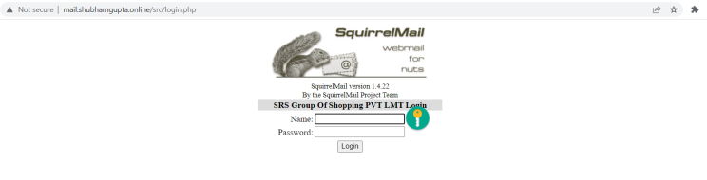
# yum module list php
# yum module enable php:remi-7.4
cd /var/www/html/
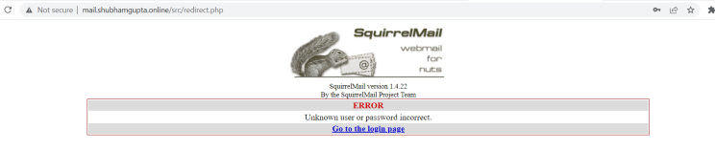you can't login the mail server becoz you have to make Dir where mail are save
# systemctl restart httpd
# systemctl restart postfix
# systemctl restart dovecot
cd /var/local/
# mkdir -p squirrelmail/data
# chown -R apache squirrelmail/
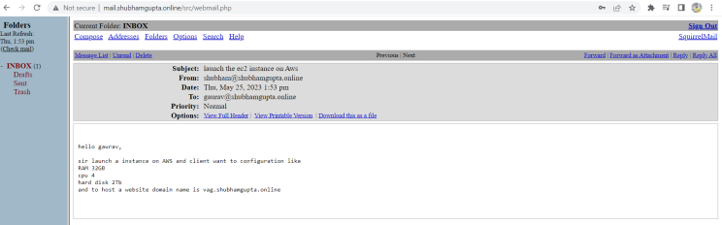my mail server successfully configure my mail server
# systemctl restart httpd
# systemctl restart postfix
# systemctl restart dovecot

I want to Secure my mail-server
# yum install certbot python3-certbot-apache mod_ssl -y
# systemctl restart httpd
**** if you want to SSL/TLS of ypur domain then you will have to do virtual host of your mail server ************
# vim /etc/httpd/conf.d/mail.conf
^ <virtualhost *:80>
servername mail.ica.online
documentroot /var/www/html
RewriteEngine on
RewriteCond %{SERVER_NAME} =mail.ica.online
RewriteRule ^ https://%{SERVER_NAME}%{REQUEST_URI} [END,NE,R=permanent]
</virtualhost>
# vim mail-le-ssl.conf
^ <IfModule mod_ssl.c>
<virtualhost *:443>
servername mail.ica.online
documentroot /var/www/html
SSLCertificateFile /etc/letsencrypt/live/mail.ica.online/fullchain.pem
SSLCertificateKeyFile /etc/letsencrypt/live/mail.ica.online/privkey.pem
Include /etc/letsencrypt/options-ssl-apache.conf
</virtualhost>
</IfModule>
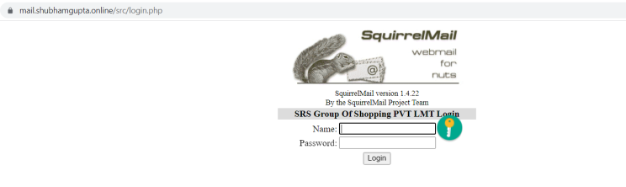
# certbot --apache
# systemctl restart httpd



